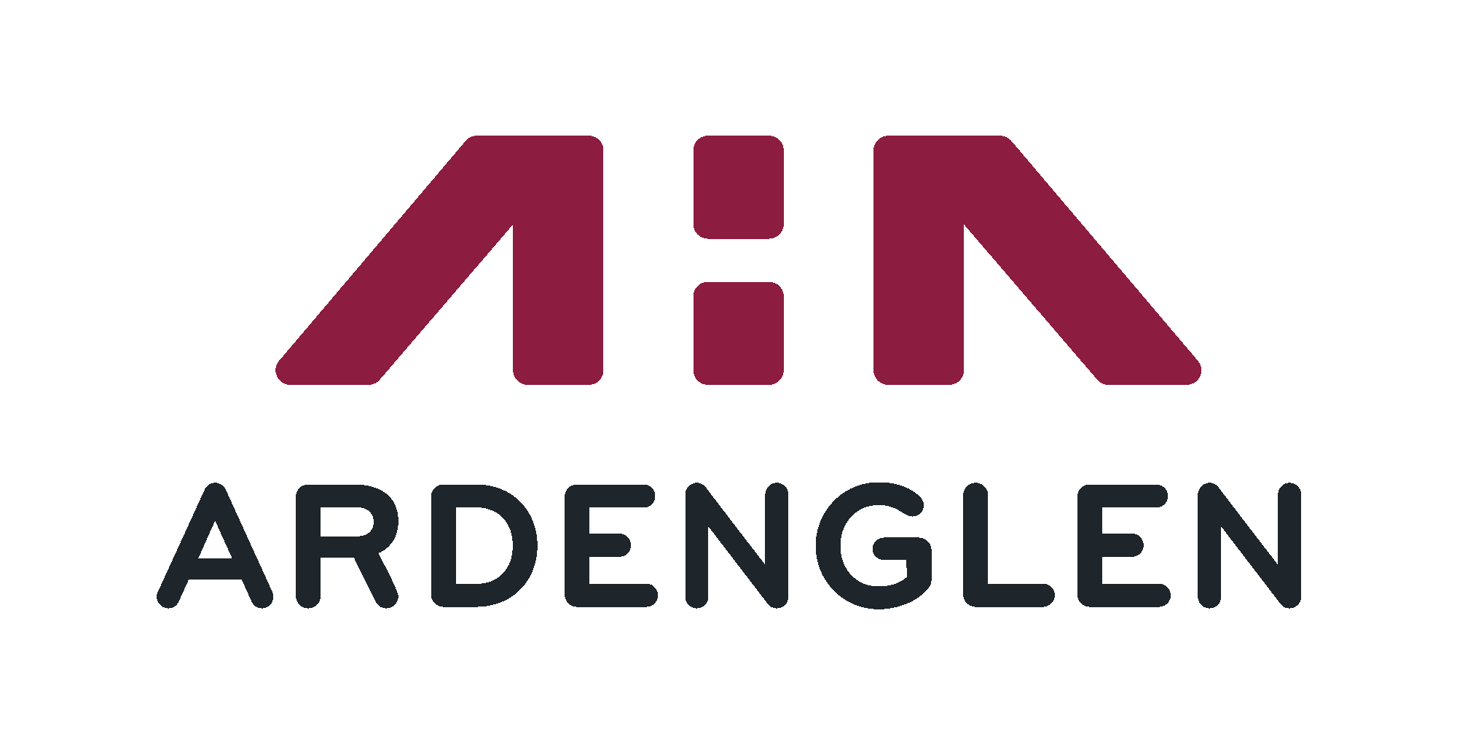

Membership Policy

Policy Title: | Membership Policy
Policy Author: | Jacqui Mills
Date of Approval: | 20 April 2021
Date for Next Scheduled Review: | 2024
Review Body: | MC
Equality Impact Assessment Complete: | No
Policy Published on Web: | No
Scottish Social Housing Charter Standard | N/A
Scottish Housing Regulator Standard: | 6
Scottish Housing Regulator Guidance: | 6.1, 6.4

Vision
Transforming communities by providing aspirational homes and services to enhance the quality of life for our customers.

Values
- Customer and Community Focussed
- Accountable
- Making a difference
- Innovative

Strategic Objectives
Deliver first class customer services
Provide quality homes, communities and sustainable tenancies
Achieve robust financial management and governance excellence
Empower, develop and engage our staff
Build strong collaborative relationships locally and nationally

Ardenglen Housing Association can provide this procedure on request, in large print, in Braille, on tape or in other non-written format, and in a variety of languages.

MEMBERSHIP POLICY

1. INTRODUCTION
Ardenglen Housing Association (Ardenglen) is a charitable housing association serving communities in the south east of Castlemilk, and aims to attract people from the groups and communities it serves to become members of the Association.

Ardenglen seeks to establish a wide, active and inclusive membership by recruiting individuals with an interest in the work of the organisation and to make effective use of the skills, experience and views of its members.

Our shareholders (described as “members” in this Policy) are local residents who have taken a £1 share in the Association.
Members of Ardenglen are those people who hold a share in the Association and whose names are entered into a Register of Members. It is a requirement of membership that members are supportive of the aims and objectives of Ardenglen.

The overall aim of this policy is to ensure we have a membership which is as open, inclusive and widely reflective of the communities we serve as possible.

2. LEGAL AND REGULATORY REQUIREMENTS

The Association is registered under the Co-operative and Community Benefit Societies Act 2014 (2339 R (S)) and is a registered Scottish Charity (SCO32542). We are constituted under the SFHA Model Charitable Rules.
The Scottish Housing Regulator (SHR) and the Office of the Scottish Charity Regulator have both approved the Association’s Rules. The Rules and this Policy ensure that we meet the Constitutional Requirements that have been set by the SHR.
The Membership Policy takes account of our Rules, legislative and regulatory requirements and good practice advice. In the event of a conflict between this Policy and the Rules, the Rules will prevail.
3. PROMOTION OF MEMBERSHIP
Ardenglen will promote membership in a number of ways in which ensures people have the opportunity to make an informed decision about whether or not to become a member.

We will promote membership of Ardenglen by circulating information on membership to tenants, owners and the local community.

Information on membership will be provided via newsletters, website, resident meetings, tenant’s conferences, new tenant visits, tenancy sign-up and other general contact with our residents and service users.

Board members and staff will actively encourage eligible people to join.

We may utilise the services of EVH’s Register of Committee Members or advertise externally to ensure that we can have access to suitably qualified and experienced people who may have an interest in joining the Board. This is subject to Ardenglen identifying a need to attract Board members with specific skills and expertise.

4. WHO CAN JOIN
Ardenglen seeks to ensure broad representation in its membership of the groups and communities that it serves. To this end, the Association will particularly welcome applications from:
- Tenants of Ardenglen
- Other residents living in East Castlemilk
- Others who can contribute particular community, business or professional experience or skills.

Ardenglen seeks to ensure that its membership reflects the communities it serves and that all sections of the community are represented. The Association wishes to achieve a broad based membership that is representative of the communities we serve. Membership is open to all sections of the community, and we are particularly keen to encourage shareholding membership by:
- Ardenglen Housing Association tenants and other customers (e.g.
sharing owners and factored owners)
- People from groups who are currently under-represented within our
shareholding membership in the areas where we are active.

Ardenglen also seeks to recruit as members those with a particular interest in the running of the organisation. To this end, the Association welcomes applications form those with experience or interest in:
- housing management
- building and maintenance
- financial management
- HR management
- community care issues
- working in the local community

The Association accepts applications from organisations as well as individuals, in accordance with the rules relating to representing an organisation.
5. APPLYING FOR MEMBERSHIP
Applications for membership shall be forwarded to the Association’s registered office either on-line or in writing and should include the sum of £1.00.

A membership application form will be provided to all new tenants.

Every application is considered by the Board at its next meeting after the application is received, or as soon thereafter as is practicable.

If the application is approved the applicant will immediately become a member of Ardenglen and the name will be included in the Register of Members within seven working days. The member will then be issued one share in Ardenglen, which is non-refundable and non-transferable.
Whilst it is the Association’s intention to encourage membership, the Board has absolute discretion in deciding on applications for membership, taking full account of this Policy and the Rules of the Association.
The Board of Management will not consider applications for membership within the period of 14 days before the date of a general meeting of the Association.
An indication of areas where there may be grounds for refusal are as follows:-

- Where the Association rules or policies prevent membership (e.g. Applicant is under 18 or the Applicant is a member of staff);

- Where a conflict of interest may exist which would, even allowing for the disclosure of such an interest may adversely affect the work Ardenglen.

- It is considered that this ground may extend to individuals with an
occupational or financial interest in property development or speculation,
or an employee or committee member of another Housing Association
with a competing interest.

- Where the Board suspects that the application is part of an organised attempt by narrowly defined interest groups who are hostile to the principles of local accountability, equality of treatment and tolerance or has grounds for believing that the applicant does intend to participate in normal membership activities. Examples of this are attempts by a local political party grouping, or sectarian or racist groupings which do not support the overall aims and objectives of the Association.

- The Board recognises that the refusal of membership applications on
this ground must be made in an open and accountable fashion and
should not be used to undermine attempts to make the Association
locally accountable and representative.

Where an application is unsuccessful, a statement of the reasons for refusal will be given. An applicant will then have one further opportunity to request membership, and to give reasons why the decision should be changed; this should normally be made in writing. The Board will consider the reasons at its next practical meeting and its decision on that occasion will be final.

Other provisions relating to membership are as follows;
- If the membership application is agreed a share certificate will be issued to the applicant and his/her name will be entered in the register of members; and

- No member shall hold more than one share in Ardenglen however, a household may have more than one member within it.

6. RIGHTS OF MEMBERS AND MEMBER PARTICIPATION
The Association’s members have important constitutional rights, set out in the Rules. These include rights to:
- Attend general meetings of the Association;
- Vote at general meetings;
- Elect the Association’s Board members;
- Be nominated for election to the Board of Management;
- Nominate other members for election to the Board of Management;
- Appoint the Association’s auditor, and receive the annual accounts and
any annual reports
- Vote on changes to the Association’s Rules
The Association will take the following steps to ensure that members are well informed and can actively participate in the Association’s affairs:
- Provide all members with an annual report;
- Publicise general meetings at least 14 days before the day of the meeting;
- Provide information that allows members to make informed decisions at general meetings. Where information in a particular format or language is required, the Association will make all reasonable efforts to provide this;
- Make efforts to hold general meetings at times and locations that are accessible to all;
- Promote opportunities for serving on the Board of Management

7. TERMINATION OF MEMBERSHIP
Membership will cease when a member:
- Resigns by giving written notice to the Secretary.
- Becomes an employee of the Association
- Is expelled in accordance with the Rules.
- Changes address but does not notify the Association of their new address within three months, unless the new address is also a property of the Association.
- Fails to attend or to submit apologies for a set number of Annual General Meetings as set out in the Rules
- Dies, subject to the provisions outlined in section 17.1,17.2 &17.3 of the Rules.

The Board will end the membership and cancel the share. The £1.00 membership is non-refundable on termination of membership. The value of this share will then belong to the association and transferred to our revenue reserves.

8. EQUALITY & DIVERSITY
The Association wishes to ensure that our membership is representative of the communities we serve. We welcome membership applications from all sections of the community who meet the qualifying criteria for membership, regardless of age, sex, race, disability, sexual orientation, gender identity, religion or belief.
Any person attending events such as general meetings must always show respect towards others. We will not tolerate behaviour that is at odds with our commitment to equality.
9. POLICY REVIEW
The Board of Management will review periodically the results achieved in promoting membership and the profile of the membership. Where appropriate, the Board of Management may decide actions to be taken, for example to promote membership from groups that are currently under-represented.
Prior to each Annual General Meeting, the Board of Management shall receive a confirmation on compliance with Rules 62 to 67 in the Secretary’s Report, including the requirements relating to the Register of Members that are set out in Rules 64 and 65.
The Membership Policy will be reviewed in 3 years’ time., or sooner in the event of significant legislative or regulatory developments which affect this Policy.

